Exercise 1.

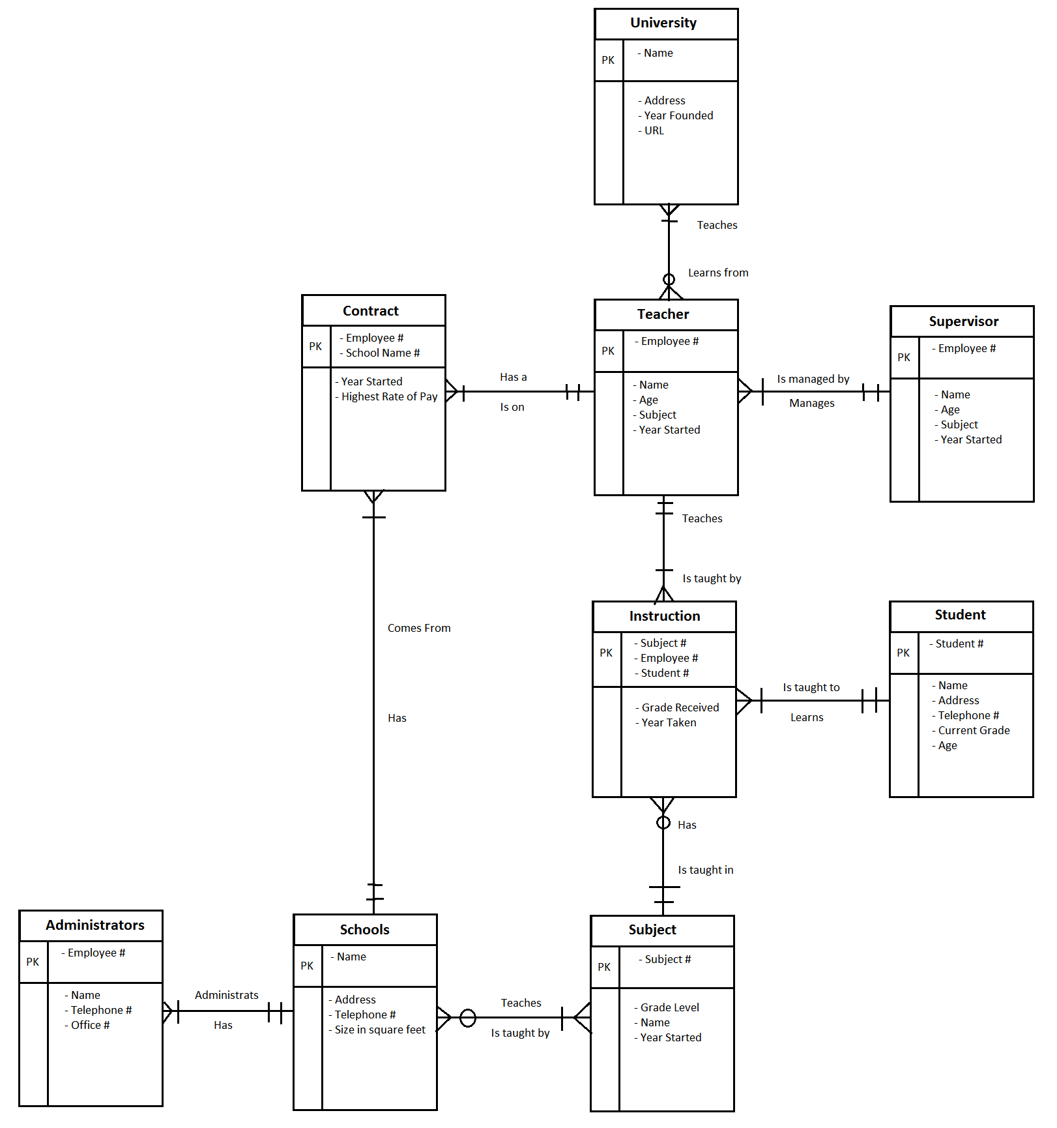

Exercise 2.   
This environment starts with a store that has a unique store number that had a city, country and telephone number. Each store owns and least 1 disk and can own multiple disks. These disks can only exist in one store. The disks have a unique serial number and a type.

Each disk is can part of a rental or multiple rentals. These rentals must have at least one and only one disk associated with it. The rentals also have unique serial numbers, customer numbers and dates. They also have the rental price. These rentals must be rented by a customer and only one customer. Each customer must have one rental and can have multiple rentals. The customers have Customer Number that is unique as well as a name, address and telephone.

Each Disk also has a movie on them and only one movie. These movies can be on multiple disks but must be on at least one. The movies have a unique title as well as the length and the year created. The movie can have one actor and only one actor on the movie. Actors can be one no movies or multiple movies. Each actor has a unique names as well has date of births and nationality.

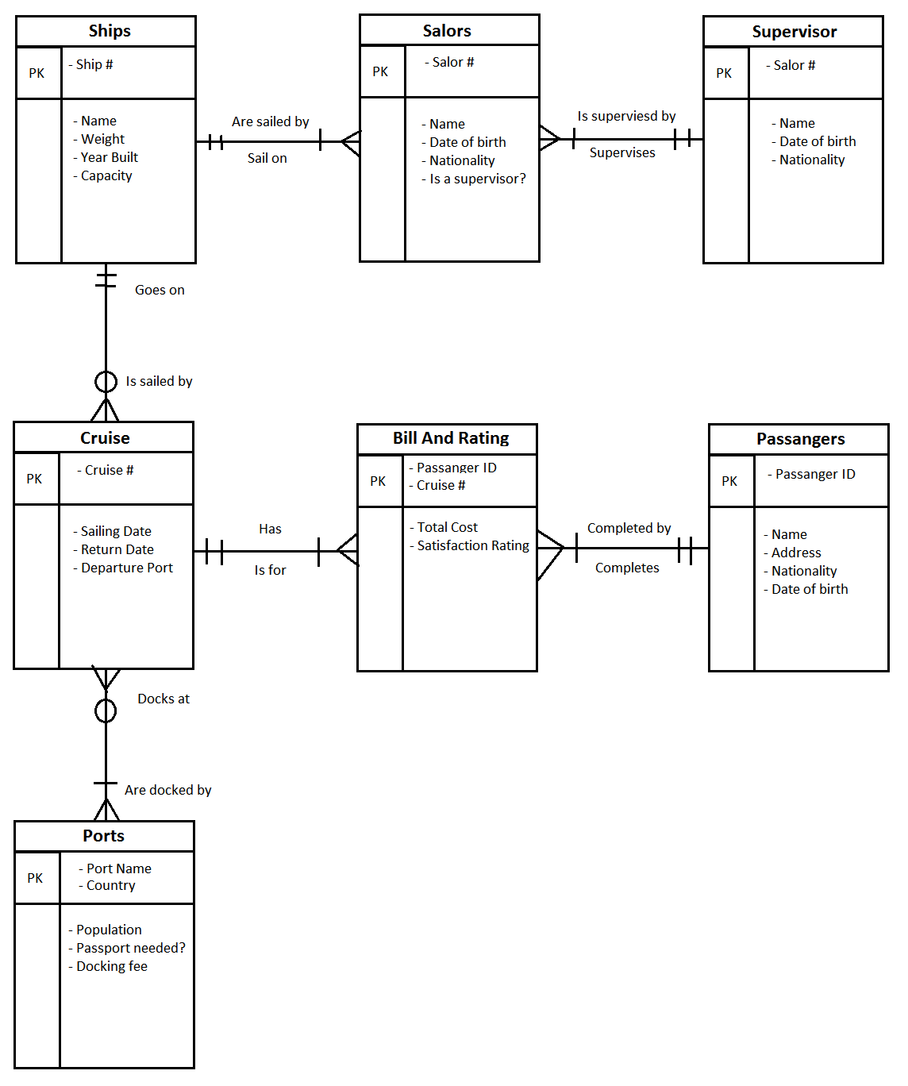Mini Case: